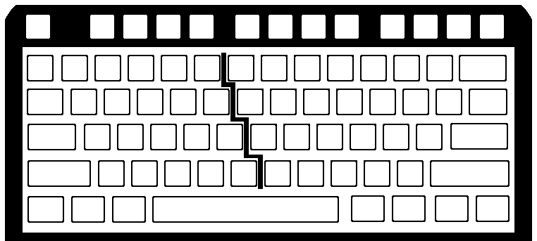
Name_______________________________ Date_______________ Grade _______________ TEST 2
Fill in the MISSING Home & Top Row Letters /19 pts

4
5
6
7
8
9
0
-
=
BS

R
T
Y
U
I
O
P
[
]
\
F
G
H
J
K
L
;
‘
ENTER
B
N
M
,
.
/

[Type a quote from the document or the summary of an interesting point. You can position the text box anywhere in the document. Use the Text Box Tools tab to change the formatting of the pull quote text box.]
Using only the letters you just filled in on the KEYBOARD; create at least 5 real words which you can make to practice these keys.

1.

2.

3.

4.

5.

[Type a quote from the document or the summary of an interesting point. You can position the text box anywhere in the document. Use the Text Box Tools tab to change the formatting of the pull quote text box.]
Write a description of how you need to save a word processing document to your slice of the cyber world AFTER the document has already been opened….. /5 pts
___________________________________________________________________________________________________________________________________________________________________________________________________________________________________________________________________________________________________________________________________________________________________________________________________________________________________________________________________________________________________________________________________________________________________________________________________________________
[Type a quote from the document or the summary of an interesting point. You can position the text box anywhere in the document. Use the Text Box Tools tab to change the formatting of the pull quote text box.]
Write the LETTER you would hit with the key stroke described……. /2 pts

_________ Right Hand Ring Finger UP _________ Left Hand Index Finger

Write the FINGER and HAND that would be needed to hit the LETTER described……. /4

_W_ ________________ Hand ______________Finger _P_ ______________ Hand _________Finger

________
1
2
3
4
5
6
7
8
9
0
-
=
BS
[
]
\
;
‘
ENTER
Z
X
C
V
B
N
M
,
.
/
TAB
CAPS
SHIFT
SHIFT
`
Space Bar
CTRL
CTRL
ALT
ALT

